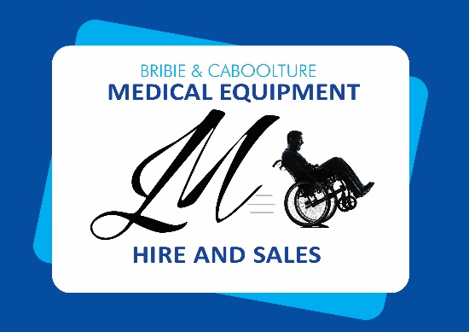
Sovereign S7 Ultimate Care

Foam Surface
SKU: S7KS1000PU (KS)
SKU: S7KSL1000PU (LKS)
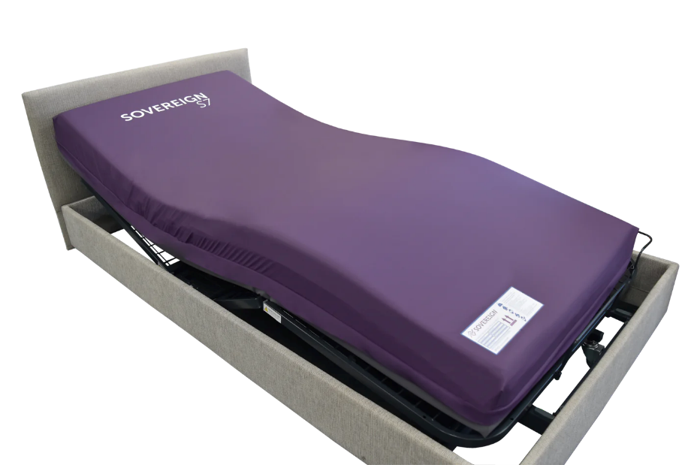
Features and Benefits:
Game Changing Foam Innovation

Breathability

Improved Micro-Climate

Next generation Ventraflow® provides unrestricted Air Movement which takes heat and moisture away from pressure areas with unique Air Channel System.

Adjustable Comfort

Reversible comfort immersion layer;

Airoform® cooling Gel memory foam.

Improved body temperature regulation

Airoform® Response.

Highly elasticity for reduced effort while repositioning

Ease of Repositioning

Ultra-high rebound foam technology makes it easier to roll and reposition.

The S7 is suitable for High Risk clients, with a weight range between 30 – 250kg.

$2,224
Specifications (King Single)
- Depth (mm) – 190
- Length (mm) – 1980
- Width (mm) – 1050

$2,435
Specifications (Long Single)
- Depth (mm) – 190
- Length (mm) – 2030
Width (mm) – 1050

