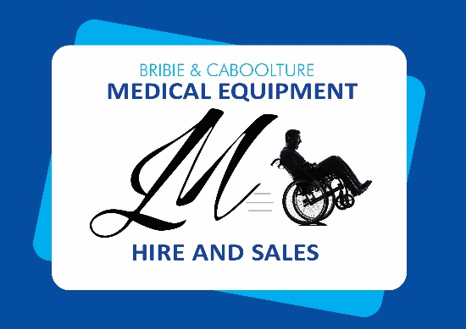
Avante Hi Lo Flex

Base Only
SKU: AVHLKSAB.OC (KS)
SKU: AVHLLDAB.OD (LKS)
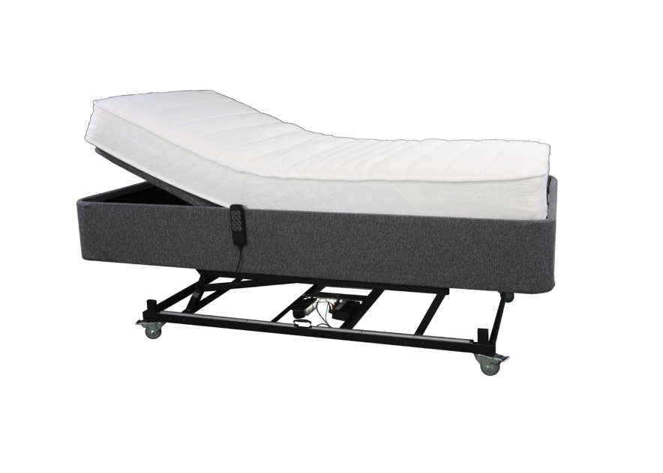
SKU: AVHLLSAB.OD (LS)

Features and Benefits:
The Hi-Lo is a Mobility focused Adjustable bed that doesn’t look like a traditional hospital bed.

With its Hi-Lo mechanism, safety sensors, under bed lighting and optional side rails, this bed is a cost-effective solution that won’t compromise your décor.

- Hi-Lo Lift Function

- Safety Sensors

- Under Bed Lighting

- Low Point: 340mm (base only)

- High Point: 620mm (base only)

- Wired Hand Control with backlight

- Side Rails Optional

- 180kg Weight Rated

- Available in 4 different sizes

Specifications (King Single) - $2,990
- Depth (mm) – 190
- Length (mm) – 1980
- Width (mm) – 1050

Specifications (Long Double) - $3,470
- Depth (mm) – 190
- Length (mm) – 2030
Width (mm) – 1050

Specifications (Long Single) - $2,850
- Depth (mm) – 190
- Length (mm) – 2030
Width (mm) – 1050

